Learning Journal Unit 4

1. Reflective Comments

Sunday 5th December

I reviewed the last 3 week’s work in MATH1280 as I felt I didn’t quite give it my best and understand it properly. This involved going over the assignments again and reading through the learning guides and hand guides.

Monday 6th December

I reviewed all of the video links provided in the course so far. A few of them I had to watch two or three times before I fully understood what they were saying as it can be a lot of information to absorb in one go.

Tuesday 7th December

I completed the self-quiz and the discussion assignment. The self-quiz was quite a challenge, but I kept at it until I got it right and understood all the answers and why mine were wrong and made notes for the final exam of all my mistakes. The discussion assignment was interesting, reading through how other people see probability, and waiting on feedback for my coding solution of a Boolean true or false.

Wednesday 8th December

I completed the learning journal and the written assignment. The learning journal questions were quite simple and straight forward. The written assignment took me a few hours to complete though, as there are so many questions and I wanted to make sure I get as many of them correct as possible and do not struggle as I did with the self-quiz.

1. a) The x-bar is a range chart, it shows how the mean changes over time.
2. b) The mu refers to the mean of a population.
3. c) The x-bar is the mean of a sample while the mu is the mean of a population.
4. a) When you multiply each value with its corresponding probability, and then add all the values up, you get the exact same effect as if you added all the values together and divided by the number of values added. An example of me doing this in R is provided in the screenshot below:

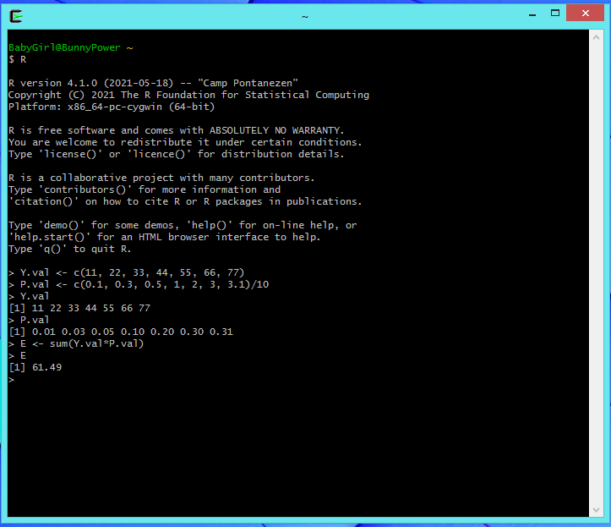

1. b) My calculation is multiplying each value with its corresponding probability, making each number smaller so that a division by the amount of numbers added together is not necessary. My mean is calculated inclusive of the probability of each number appearing. My probability is scaled so that the greater numbers located to the right have a higher probability range, which is why my mean is above 60.

Total Words (407)